## **DevOps Bootcamp – Assignment 1**

1. **Create a local git repository developerA and create 3 files into it. (demo1,2 and 3)**

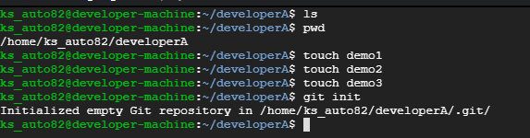

1. **Add all the 3 files into staging area and commit it in the local repository.**

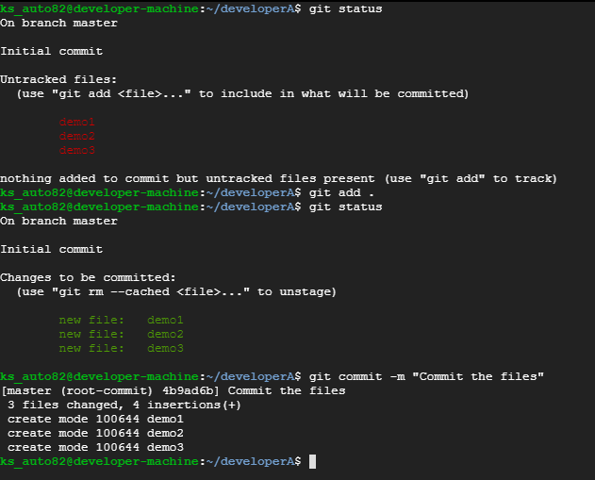

1. **Create a remote repository.**

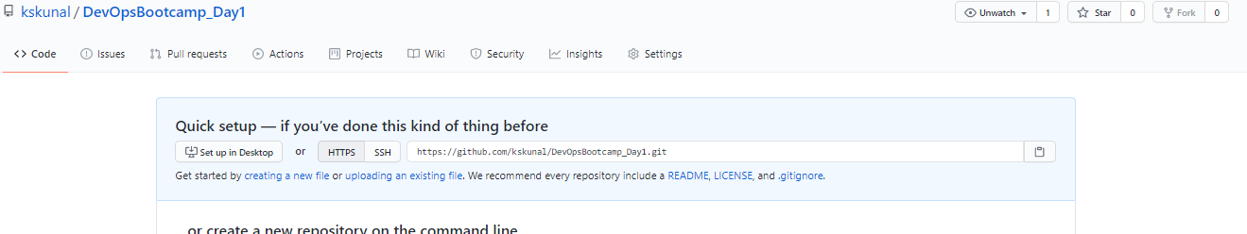

1. **Add the remote repository to the local repository and push the changes to the remote repository from local repository.**



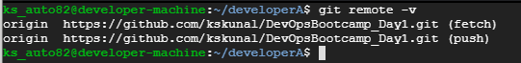

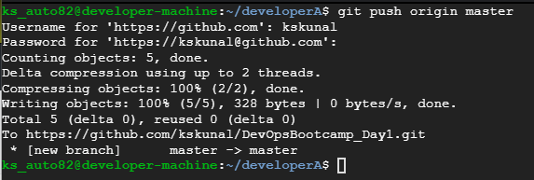

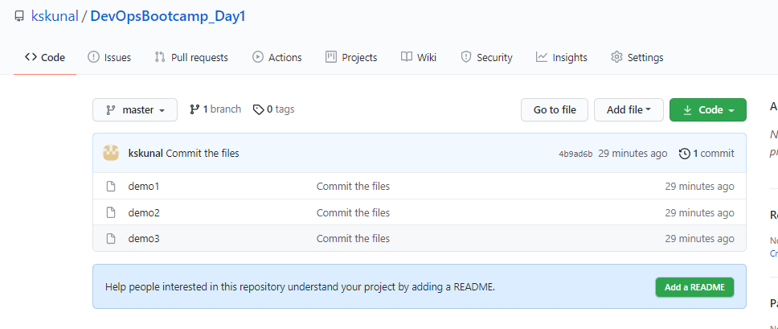

1. **Clone the remote repository to another folder developerB.**

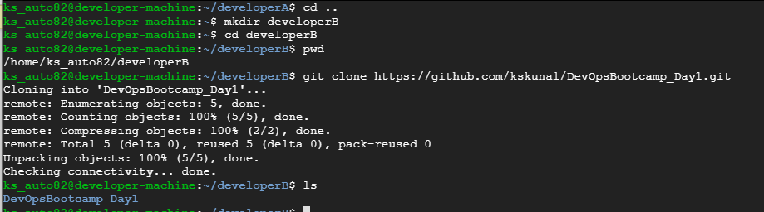

1. **Make and commit the changes via developer B and synchronize the changes in developer A repository.**

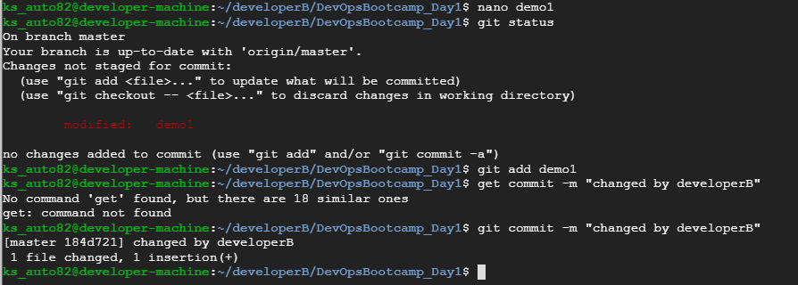

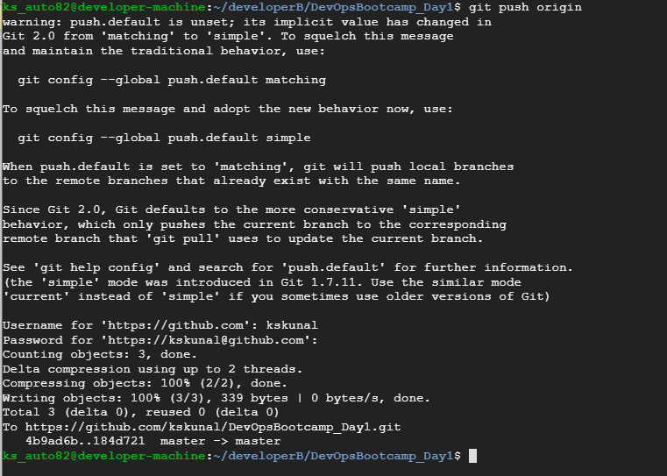

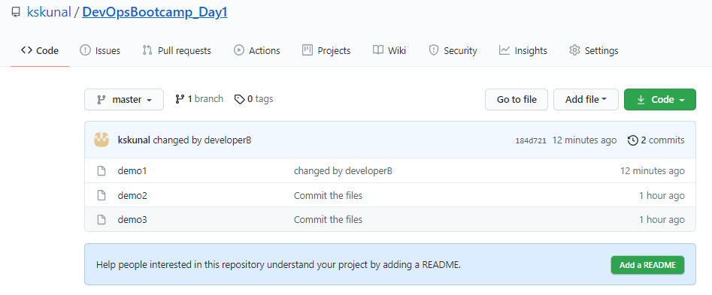

1. **Create a new branch for a new feature you want to add to the application(say feature1) and change the files.**

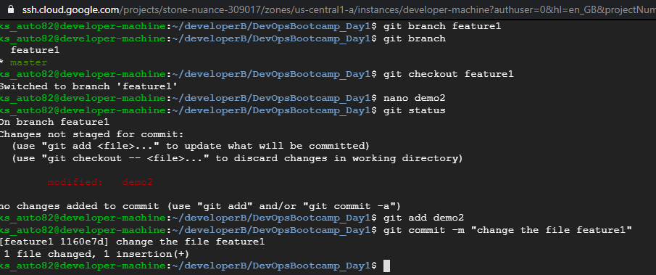

1. **Merge back the created branch with the master branch**

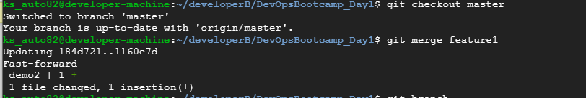

1. **Delete the feature1 branch after merging.**

